Pineapple Game IDE 1.0
Functional Specification
Last Updated: July 5, 2009

Overview
Pineapple is a Game IDE aimed towards users with some programming knowledge or who intend to learn to code.
This specification is ONLY A DRAFT.

Target Audience
In order to better explain the concept of Pineapple, we will consider here stereotypical cases of users. This is an attempt to better define Pineapple relatively to the needs of users.
In first place, we'll consider an user that came from the world of Java. He actually developed a few applications using visual designers. He tried to make a game in it, but the difficulty of manually defining the position of objects on the screen made him look for something that positioned the objects automatically.
In second place, we'll imagine some user that has used some game making application(s) in the past and decided to give Pineapple a try, just to see how it was.

Pineapple Interface Overview
When an user enters Pineapple, the following interface should appear:
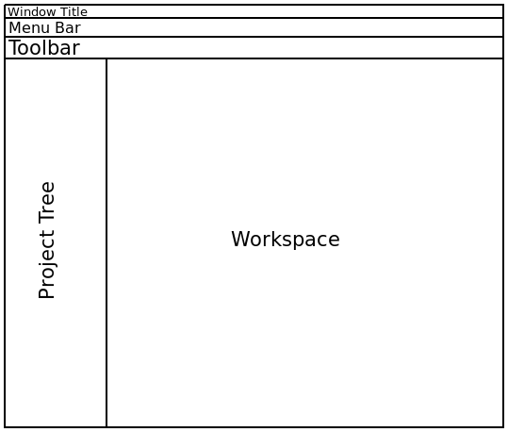
Note that the window title bar should be managed by the operating system, appearing native.
Also, the project tree should appear on the left by default, but it can be undocked or dragged to other parts of the window.

Pineapple Menu Bar
The menu bar should have the following menus and menu items(in order):

- File
- New
- Project...
- ----Separator----
- Folder
- (List of commonly used file formats)
- ----Separator----
- Other...
- Add File
- Delete File
- ----Separator----
- Open Project...
- Open File...
- Save File(Enabled only if the current file contains unsaved modifications)
- ----Separator----
- Exit
- Edit
- Find in Project
- ----Separator (only visible if there are more options)
- (The exact contents depend on the type of open file)
- Tools
- Manage Plugins...
- Options...
- ----Separator----
- Create Sprite From Image
- Game Settings... (only if current project is a game)
- Compile Game...
- Help
- Getting Started/Documentation
- About Pineapple

Projects are saved automatically, and therefore they do not require a specific menu item.

Pineapple Toolbar
The toolbar should consist on buttons with 32x32 images of obvious meaning and no textual labels. Placing the mouse over those images will show a tooltip with a few words(like “New Game Project”) explaining what the button does.
The toolbar should have buttons for the following actions(in order):

- New Game Project
- Open Project
- ----Separator----
- Import File (enabled only if a project is open)
- New Actor File (enabled only if a project is open)
- New Scene File (enabled only if a project is open)
- New PineDL File (enabled only if a project is open)
- ----Separator----
- Game Settings (enabled only if a project is open and is a game project)
- Compile Game (enabled only if a project is open and is a game project)
- ----Separator----

After these items, a few more may appear, depending on the type of the currently opened file.

Open Issue: Should the toolbar be relocatable?
Open Issue: Some users proposed using split buttons. Would this lead to a better interface?

Pineapple Project Tree
The project tree should be empty is no project is open.
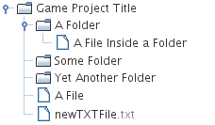
If one project is open, though, it should appear in the tree. The project itself should appear as a folder with the Project name. Inside it, the project folders and files should appear.
If a file ends with an extension(like “.txt” or “.actor”), then the extension should be grayed.
Right-clicking a node should show a menu. The exact contents of this context menu depend on the node it's being applied to.
When Pineapple is started, the last edited project should be automatically open.

The Workspace
The workspace is where the documents are displayed and edited.
By default, the workspace is uses a tabbed environment and no alternatives are available, unless third-party plugins are installed.
Even if the tab component is split, there must be the notion of the “current file”, which is the last component having been focused if multiple are visible.

Welcome Screen
When an user starts Pineapple, the workspace should have a “Welcome!” tab by default.
The welcome tab should be visually appealing but not disturbing and must be newby-oriented.
Below is an image showing the layout, but not the look of the Welcome screen.

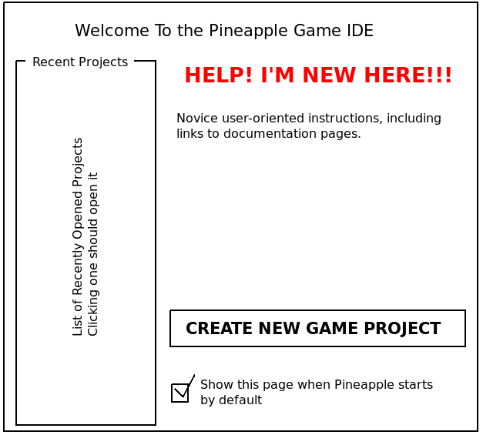
Notice “HELP! I'M NEW HERE!!!” appears in bigger fonts and a different color to be immediatly noticeable by users who don't know where to start.
Disabling the checkbox on the bottom of the welcome tab will prevent the “Welcome!” window from appearing by default when Pineapple is started.
The new Game Project button, along with the “New Game Project” toolbar button, is there to encourage users to create a new Game Project instead of generic default Pineapple projects.

The Text Editor
The Text Editor should provide a simple way to edit plain text files, such as those with the “*.txt” format.
If the edition pane is too big to fit on the tab, scroll bars should appear.
Also, this editor should support undo, redo, cut, copy and paste.

The Image Viewer
The Image Viewer should be the default Pineapple handler of images. It is not capable of editing images itself, though.
The image viewer should display the image that corresponds to the open file. If the image is too big to fit on the tab, scroll bars should appear.
On the bottom-right corner of the viewer, a slider should appear to let the user configure the zoom of the image. The default should be 100%.

Note: By default, we should officially encourage the usage of PNG files, but also support BMP, GIF and JPEG images. We may, however, support other formats.

The Sprite Editor
The Sprite Editor should provide a way for the user to create his/her own sprite resources.

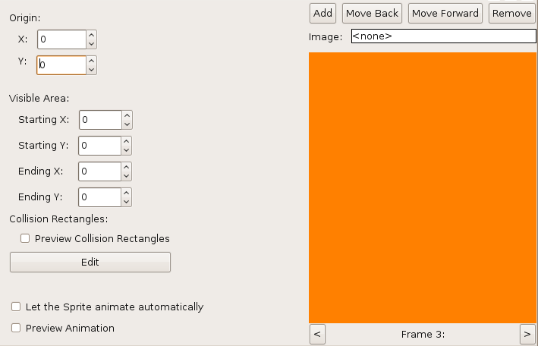

The orange area in the image above represents the image previewer.
Each sprite has several images associated with it. If the “Add” button is pressed, the currently selected image(the value of the resource chooser after the “Image:” label) is added to the sprite. Note that the same image can appear in the same sprite multiple times. Each time that image appears is called “Frame”. The various frames are ordered by “index”. The “Add” button should add an image(frame) to the final index.
The “Remove” button should be disabled if there is only one image on the sprite. Clicking on it should remove the currently viewed frame. The index of all sprite frames should be updated.
The “<” button should change the currently seen image to the previous and the “>” button should change it to the next. The “Move Back” button switches the index of the currently seen frame with the one before it and the “Move Forward” button switches the index of the currently seen frame with the next one.

Note: Moving to Frame 0 should be equivalent to moving to the last frame. Moving to after the last frame should be equivalent to move to Frame 1.

The “Move Back”, “Move Forward”, “<” and “>” buttons are disabled if there is only one frame on the sprite.

Open Issue: We still need to figure out a way to allow the user to easily set the speed of the animation and time for each frame.


The image previewer should show the current frame and, on top of it, a small cross should appear in the origin location. The visible rectangle should appear as well. The collision rectangles should be visible only if the “Preview Collision Rectangles” option is enabled.
If the image is too big to fit on the previewer, then scroll bars should appear.
Also, the background is a pattern of gray and white squares, so that the user can better know if the image is transparent or translucent.
Clicking the image on the borders of the visible rectangle and dragging the mouse should move the visible rectangle.

Note: It is hard to demand a user pixel-precise actions. For visible rectangle drag start, allow a small tolerance of a few pixels.

Clicking the image anywhere else should set the origin location to the mouse position. Dragging the mouse from a non-visible rectangle area should change the origin location to the mouse position.
The “Origin” and “Collision Rectangle” spinners exist only to make pixel-precise setting easier.
If the “Preview Animation” mode is triggered, the “<”, “>”, “Move Back”, “Move Forward”, “Add” and “Remove” buttons should be disabled, along with Visible area and origin setting. Clicking the image previewer should have no effect.
In “Preview Animation” mode, the image should update automatically to show the user how the animation will look. The origin and visible rectangle would show in the previewer and only the visible part of the image should be drawn.
Pressing the “Edit” button should make the Collision Rectangles dialog visible.

Collision Rectangles Dialog
The Collision Rectangles Dialog is part of the Sprite Editor.

Technical Note: Although this dialog is focused on collision rectangles, it should be ready for the addition of other shapes, including polygons and circles.

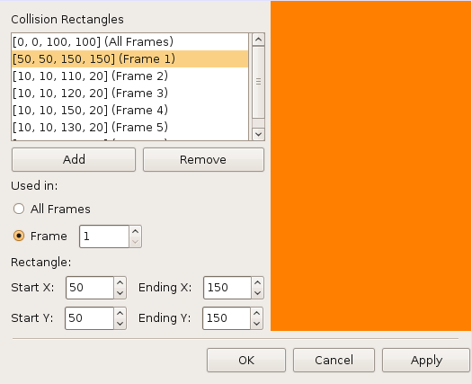
In the image, the layout of the collision rectangle dialog is showed.
The list shows all available collision rectangles. The first rectangles to appear are the ones of “All Frames”. Then, rectangles are showed ordered by frame. Only one rectangle can be selected at a time.
The labels on the list correspond to “[Start X, Start Y, Ending X, Ending Y] (All Frames/Frame X)”.
The “Apply” button is enabled only if there are unsaved modifications.
The “Remove” button, the check boxes and the spinners are only enabled if a rectangle is selected on the list.
The chooser in the “Frame” checkbox is only enabled if the “Frame” checkbox is selected.
Pressing the “Add” button should create and select a new collision rectangle as “[0, 0, 1, 1] (All Frames)”. Pressing the “Remove” button should remove the current collision rectangle.
For precise collision rectangle setting, the four spinners after “Rectangle:” are available. However, pressing the image preview should also update the rectangle.
The Image Preview(correspondent to the orange panel on the right of the image) should display the frame that the currently selected collision rectangle is applied to. If no rectangle is selected or if the rectangle is applied to all frames, then the first frame is displayed.
If the frame is too big to fit on the previewer, then scroll bars are used.
If the currently selected rectangle is applied to all frames or if no rectangle is currently selected, then all collision rectangles applied to all frames appear in gray(not filled).
If the currently selected rectangle is applied to a specific frame, then all collision rectangles applied to all frames and all collision rectangles applied to the same frame appear in gray(not filled).
The currently selected rectangle(if there is one) itself appears in black(not filled), with a line width of 3. Dragging any of the four lines of the rectangle should be possible. Clicking anywhere else on the image and dragging should replace the currently rectangle with a new one having the initial and the last mouse position as vertexes of the rectangle(but not necessarily in this order).
Pressing “Apply” should apply the changes without leaving the dialog, pressing “Cancel” should close the dialog without applying the changes and pressing “OK” should apply the changes and then close the dialog.

The Actor Editor
The actor editor

